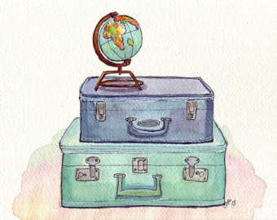
Travel and Holidays

1.
Choose the most suitable word for each space.
Holidays
Most people enjoy going ₍₁₎ _________________ for their holidays, and having the opportunity to ₍₂₎ _________________ in an interesting city or a seaside ₍₃₎ ______________________. If you speak ₍₄₎ ______________________ languages, you can make new friends, and ₍₅₎ ______________________ home some interesting ₍₆₎ _____________________ as presents. But before you can do that, you have to ₍₇₎ _______________________ your destination, and that is often a problem! If you fly, then you may find that your flight has been ₍₈₎ ________________________. ₍₉₎ _______________________ by train can also be difficult, since trains are often ₍₁₀₎ _______________________ in the summer, and you might have to reserve a ₍₁₁₎ ____________________ in advance. Whichever way you ₍₁₂₎ _____________________, you can have problems with your ₍₁₃₎ _____________________, and it is often difficult to find good ₍₁₄₎ _________________________. Apart from this, you might not be able to afford the ₍₁₅₎ ______________________!
1) | a) out | b) forward | c) abroad | d) foreign
2) | a) remain | b) pass | c) spend | d) stay
3) | a) resort | b) post | c) too | d) one
4) | a) strange | b) stranger | c) foreigner | d) foreign
5) | a) fetch | b) take | c) go | d) get
6) | a) memories | b) souvenirs | c) memoirs | d) recollections
7) | a) reach | b) arrive | c) go | d) travel
8) | a) waited | b) reversed | c) delayed | d) booked
9) | a) Journeys | b) Travels | c) Voyages | d) Passes
10) | a) filling | b) occupied | c) overdone | d) crowded
11) | a) post | b) chair | c) seat | d) position
12) | a) voyage | b) travel | c) trip | d) tour
13) | a) baggages | b) luggage | c) goods | d) sacks
14) | a) staying | b) homes | c) lodges | d) accommodation
15) | a) fare | b) fair | c) far | d) fur
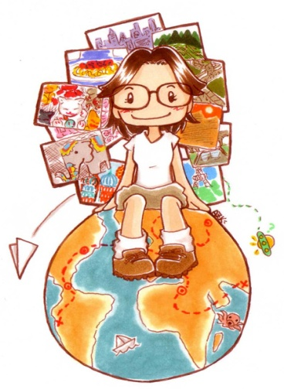

2.
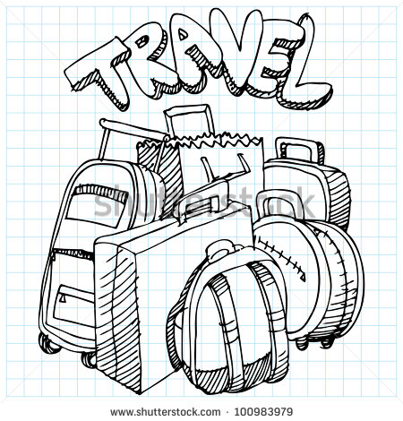
Complete each part sentence a) to j) with one of the endings 1) to 10) and make a compound word.
a) I sent my friend a post | ___ | 1) suit with you to the beach.
b) I fastened my seat | ___ | 2) table turned out to be wrong.
c) We stayed on a small camp | ___ | 3) belt, and waited for takeoff.
d) I always forget my guide | ___ | 4) port, you must tell the police.
e) Don’t forget to take your swim | ___ | 5) hiking can be dangerous.
f) If you lose your pass | ___ | 6) side when I was little.
g) We stayed in a quiet guest | _a)_ | 7) card of the town where I stayed.
h) The train time | ___ | 8) book when I visit old cities.
i) I used to like going to the sea | ___ | 9) house down by the river.
j) Nowadays I’m afraid that hitch | ___ | 10) site just outside the town.
3.
Choose the correct word
ancient exhausted local open popular reasonable relaxing seasick suntanned warm
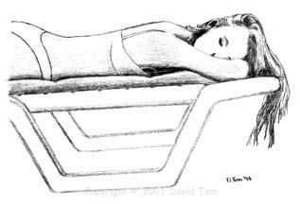
- In Greece we visited several ___________________________ temples.
- Whenever Helen travels by boat she feels ________________________________.
- Brighton is a ______________________________ seaside town.
- Holidays in the mountains are always more _____________________________.
- We always eat the ______________________________ food when we are abroad.
- On my summer holidays I like getting _____________________________.
- It may not be easy to find accommodation at ________________________ prices.
- After cycling all day, Bill was completely __________________________________.
- The owner of the hotel gave us a ______________________________ welcome.
- Jack likes spending most of his holiday in the ___________________________ air.

