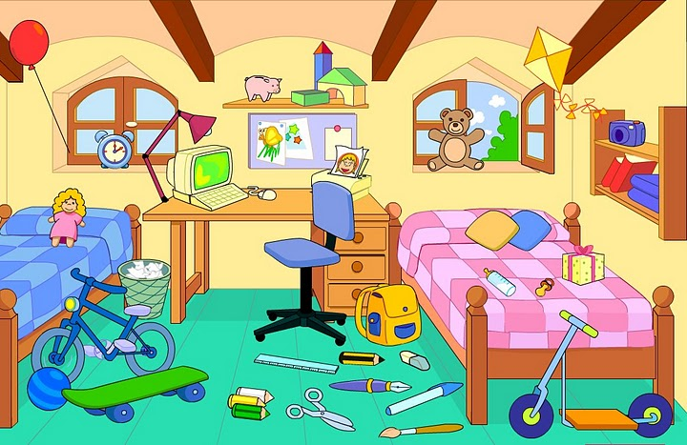
1 Doplň do vět předložky podle obrázku (on, next to, under, above, between, opposite,
behind, in front of)
1 The present is …………………….the bed.
2 The bag is ………………………..the desk.
3 The lamp is ……………………….the computer.
4 The blue ball is ……………………….the bicycle and the skateboard.
5 The books are …………………………the shelf.
6 The beds are …………………………..the windows.
7 The teddy bear is ……………………..the bed.
8 The chair is …………………………the desk.
9 The ruler is ………………………….the pencil.
10 The computer is ………………………the desk.
2 Doplňte do vět správný tvar slovesa být (is, isn´t, are, aren´t, am)
1 Where ………………….your brother? He ……………………..in the garden.
2 …………………your parents at work? No, they ………………………. . They ……………………on holidays.
3 My teacher ………………….at school today. She ……………….ill so she ……………….at home.
4 I …………………from Spain.
5 ……………………you a student? Yes, I …………………. .
6 We ……………………….Italian. We live in Rome.
7 Jane and I …………………….in the same class.
8 ………………it your dog? Yes, it ……………….. .

