Prohlášení WHO k nedávnému hoaxu o Covid 19

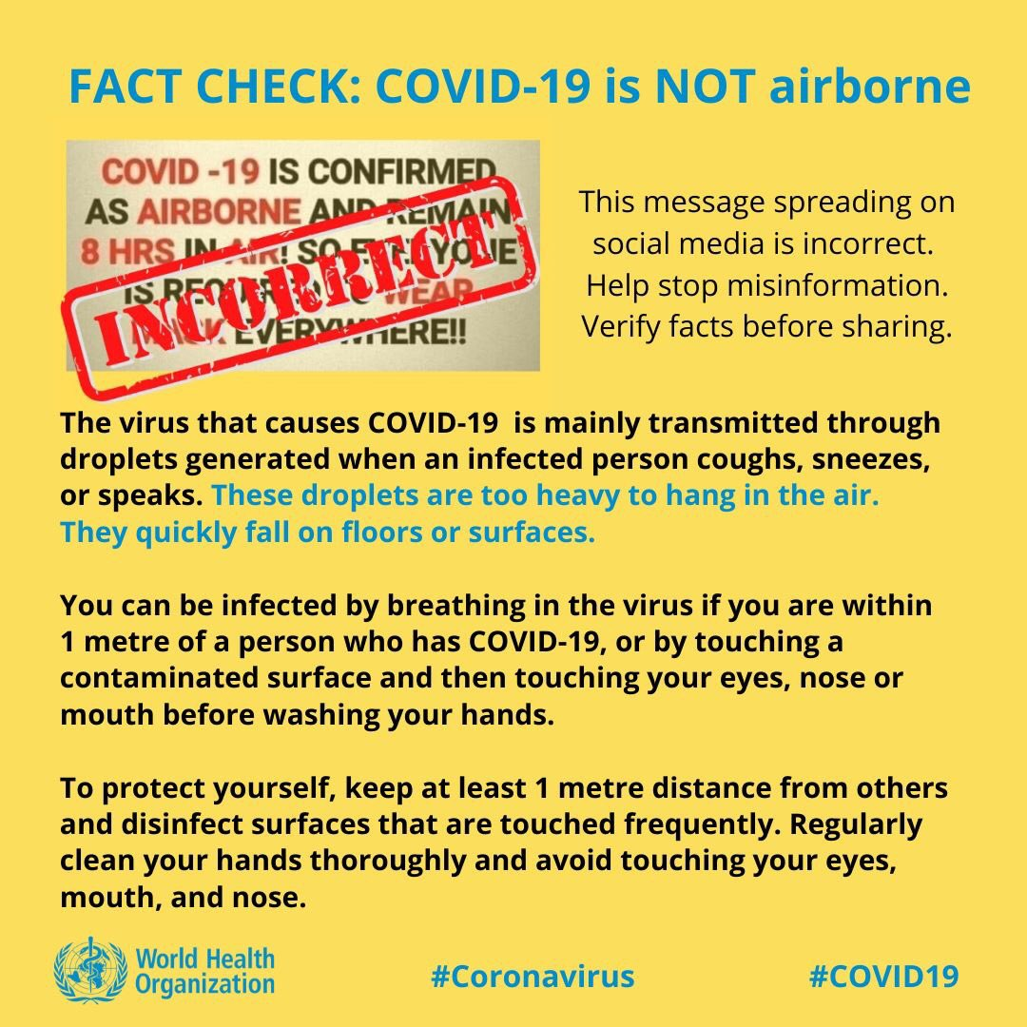

To protect yourself:
-keep 1m distance from others
-disinfect surfaces frequently
-wash/rub your
-avoid touching your

